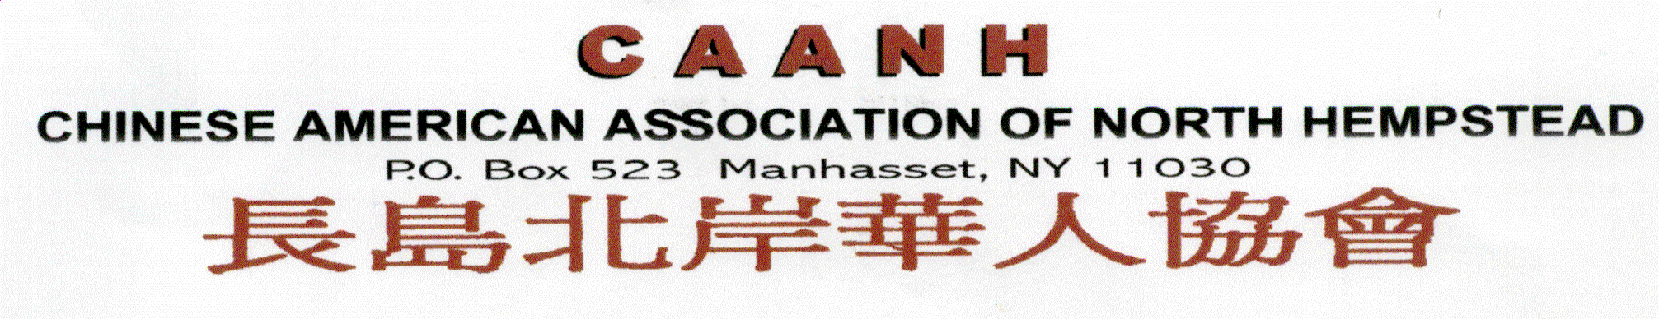

Membership Application Form

The Chinese American Association of North Hempstead (CAANH) is a non-profit organization formed in 1997 by Chinese residents of Manhasset and neighboring towns of North Hempstead. Its objectives were:
- To cultivate goodwill and introduce the Chinese culture and traditions to the community.
- To promote community participation and awareness among our members.
- To encourage quality education and sponsor scholarship programs for our children.
- To represent the interests and concerns of Chinese residents in the community.

The association organizes many social and educational events to achieve its goals and its overall mission of improving the quality of life in our community.

Name (English): ________________________________________________

(Chinese): ________________________________________________

Spouse Name (English): ________________________________________________

(Chinese): ________________________________________________

Street Address: ________________________________________________

________________________________________________

City, State, ZipCode: ________________________________________________

Home Phone: ________________________________________________

Cell Phone: ________________________________________________

Business Phone: ________________________________________________

Email Address: ________________________________________________

Children’s Name(s): _____________________ Birth Date: ____________
(English & Chinese)
_____________________ Birth Date: ____________

_____________________ Birth Date: ____________

_____________________ Birth Date: ____________

Mail completed application form and $40 lifetime membership fee (Payable to CAANH) to:

CAANH PO Box 523 Manhasset, NY 11030
Visit www.caanhli.org for additional information

