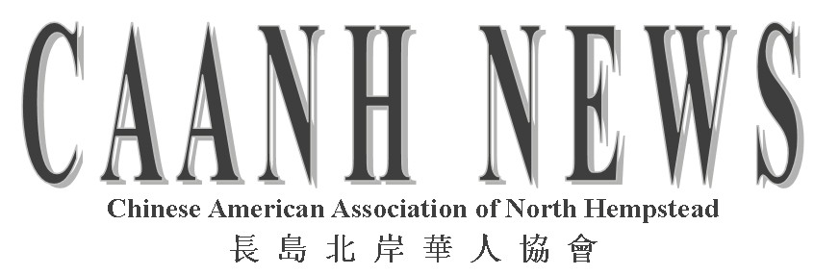
P.O. Box 523
Manhasset, NY 11030
www.caanhli.org
Fall Edition, October 2008

2008-2010 CAANH
EXECUTIVE BOARD

Alice Chan
Lana Choy  Teresa Louie  Ping Cheng  Linna Wu  Gloria Juang  Janis Woo  Shirley Chow  Joanna Lee  Cora Yim  Angela Lee  Ting Ting Dai  Sonia Chan  Carroll H | Co-President  Co-President  Vice President  Vice-President  Treasurer  Secretary  Corresponding Sec’y  Public Relations  Membership  Membership  Education  Education  Education  Activities

UPCOMING EVENTS

Welcome Party
November 1, 2008
7 PM—10:30 PM
Trinity Lutheran Church

5 Durham Road
New Hyde Park 11040

Bid on Auction Items
Free food and refreshments
Herricks Chinese
New Year Celebration

February 7, 2009
Herricks High School

Shelter Rock School
New Year Celebration
(date to be announced)

CAANH Annual Gala
Leonard’s of Great Neck
March 21, 2009

PRESIDENTS’ MESSAGE

Dear Friends and Neighbors:

We are both honored to be the newly elected co-presidents for the 2008-09 and 2009-10 terms.

We would like to acknowledge and express our thanks to our former presidents for their tireless commitment and dedicated leadership; and to all our past and present members for their continuous support and generosity to our organization. Today, CAANH is a vibrant and progressive organization consisting of over 200 families; a direct result of the continued hard work and dedication of all of you. Through this growth and continued commitment, we have made a difference in our community and greatly enriched our local neighborhoods by sharing our Chinese culture via numerous educational programs and cultural events.

We strive to continue our growth and development with the help of each and every one of you. We actively encourage and seek our neighbors to join and welcome all new and (old) members to our organization.

Historically, our organization has been very fortunate in securing the support of many sponsors and state grants through the generosity and support of our New York State Senators Michael Balboni and Craig Johnson. These funds have enabled CAANH to implement and sponsor many cultural and educational activities in both our schools and communities. We aim to continue and excel in this success.

In conclusion, we look forward to serving our community and continue to carry on the goals and exemplary accomplishments of this organization through activities that promote goodwill, education, community participation and awareness of our unique Chinese culture and its traditions. We look forward to seeing all of you and meeting new members at our upcoming events.

Best Regards,

Alice Chan & Lana Choy
Co-Presidents

CAANH HIGHLIGHTS—December 2007-June 2008
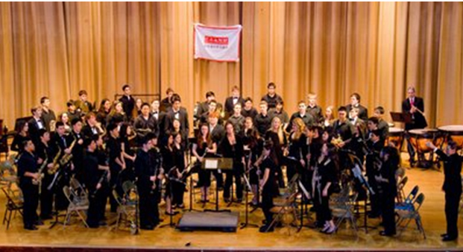
Chinese Music Festival

CAANH sponsored the Chinese Music Festival held at the Munsey Park School in Manhasset on January 26, 2008. The auditorium was seated to capacity as students from the chamber Orchestras and Wind Ensembles of Manhasset and Herricks High Schools mesmerized listeners with three well-known Chinese works. The event was held in celebration of CAANH’s tenth anniversary and ticket sales totaling $5,400 was donated to the Music Departments of Manhasset and Herricks High Schools.

1Manhasset SCA Fair

CAANH sponsored the SCA Fair at Munsey Park Field by selling 3,500 dumplings on May 3, 2008. Our dumplings are extremely popular, and one of the fair’s greatest annual attractions. We are very appreciative of the Manhasset families who precooked the dumplings for this event. Through our endeavors, we donated $1,500 to the SCA, who will use funds to support Manhasset schools.
Welcome Party

On December 1, 2007, a Welcome Party was held at Trinity Lutheran Church in New Hyde Park. A pot luck dinner was organized, and an energetic DJ provided a variety of music for dancing for adults as well as games for children. Over 200 people attended this party and everyone had a grand time.

Munsey Park
New Year Celebration

The Munsey Park School Chinese New Year Celebration took place this past February. Angela Lee, Board member of CAANH, prepared red envelopes with gifts for each student at the school. CAANH also donated 19 hard cover books pertaining to Chinese folktales, culture, and information for students at all reading levels to the school library.

Herricks Chinese
New Year Celebration

The annual Herricks Chinese New Year event was held at Herricks High School on February 2, 2008. The event drew hundreds of community residents along with students, teachers, administrators and Senator Craig Johnson. The program included lion dancing, an umbrella dance, sing-along, magic show, martial arts, fashion show and chamber music. A traditional tennis tournament and booths with crafts entertained adults and children.

CAANH Annual Gala

CAANH held its traditional Gala event at Leonard’s on March 15, 2008. Over 200 guests arrived to celebrate the occasion including Representative Mei Wah, Councilman John Liu, Councilman Angelo Ferrara, as well as Legislator Wayne Wink. We thank the sponsors of our gala: Silver sponsors —OCA-Long Island, Shanghai Commercial Bank, SPL Lewis Construction, Starside Drugs & Surgicals, Verizon, and Yung Kee Group. We also appreciate Bronze sponsors— DePinto Realtors, Everlasting Distributors, Summit Associates, and Wonton Company. There was an exciting karaoke competition and the ultimate CAANH Idol winner was Karen Lee. On the program was a wonderful face changing act which overwhelmed the audience with surprise. The raffle sales generated $3,007, and the lucky grand prize winner of the jewelry donated by Albert & Cora Yim was Mr. Chia Lung Hsiao. The event was a huge success, and guests had a truly memorable evening.

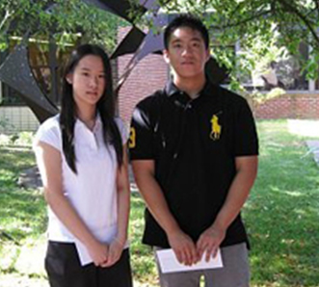
Chinese American Night

CAANH co-sponsored a cultural performance displaying the grandeur of the opening ceremonies of the Summer Olympics at Eisenhower Park on August 3, 2008. There were lion dancers, folk dancers, Shao Lin Martial Arts masters, and a popular rock band! Ping Chen & Alice Chan of CAANH were given proclamations for their community service.
CAANH
Scholarship Awards

In June 2008, CAANH provided scholarship awards to four seniors. From Manhasset High School, award winners were Christopher Chin and Marisa Moy, and from Herricks High School, they were Ryan Louie and Grace Wu (in left photo)

